Communication System

Object-Oriented Analysis & Design with UML

by

Chan Kai Kin
03011526
Wong Chun Hei
03011968
Group 11

COMP 2221
Lecturer: Prof. Jiming Liu
December 4, 2004

Table of Contents

i. Table of Contents 1
ii. Notation of Use Case Diagram 2
iii. Notation of Class Diagram 3
iv. Notation of Sequence Diagram 4
1. Introduction 5
1.1. Goals and Objectives 5
1.2. Statement of Scope 5
1.2.1. General Requirements 5
1.3. Software Context 6
1.4. Major Constraints 6
2. Usage Scenario 7
2.1. User Profiles 7
2.2. Use-cases 7
2.2.1. UC2: Login Account 9
2.2.2. UC4:Create Message 10
2.2.3. UC5: Receive Message 10
2.2.4. UC6: Draw Picture 11
2.2.5. UC7: Receive Picture 12
3. Class Diagram 13
4. Sequence Diagram 16
4.1. SD1: Use messenger to communicate with others. 16
5. Phototypes 17

Notation of Use Case Diagram

Notation of Class Diagram

Notation of Sequence Diagram
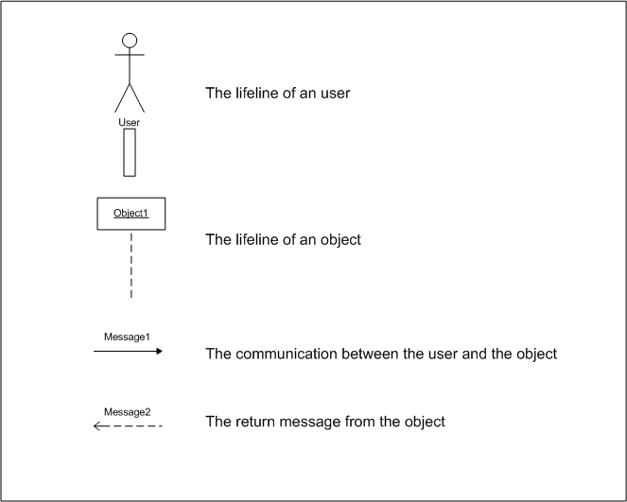

Introduction

Nowadays, on-line communication is very popular in the world, because whenever and wherever you are, if you have a computer which can connect to the Internet, you can chat with your friends or others. Besides, you can also enjoy entertainments together such as on-line games. As a result, we would like to build this software called Communication System (CS) for the sake of achieving the purpose.

Goals and Objectives

The main purpose of CS is to allow users communicating with each other. In addition, based on the system we extend functions of the software such as drawing and on-line games, so the goals of CS are:

- To provide an area for users to chat
- To provide an area for users to share their drawing
- To entertain users with games

Statement of Scope

General Requirements

The general requirements of CS are:

- A way in which users can register to be our members.
- A way in which users can login our system.
- A way in which users can chat together.
- A way in which users can draw pictures.
- A way in which users can share their pictures.
- A way in which users can play UNO game together.

Software Context

Users are connected to form a private group, in which the users can chat, play games and share drawings together. The software is good for the users doing a project discussion, because content of the project should be kept secret. On the other hand, the users can have fun together by relaxed group games.

Major Constraints

Time
Lack of time develops the extended functions based on CS such as games, so we just develop one game and one drawing function.

Usage Scenario

User Profiles

- Administrator
- End user

Use-cases

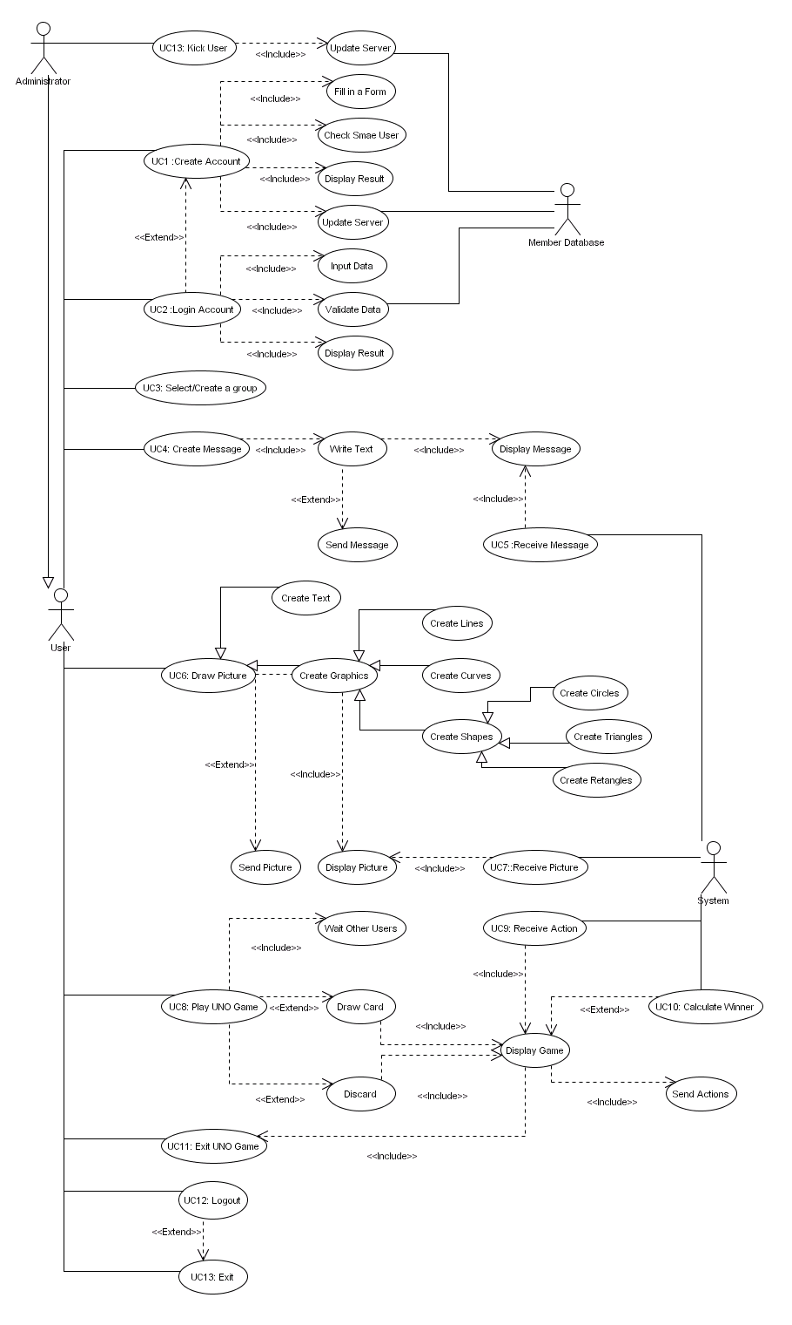
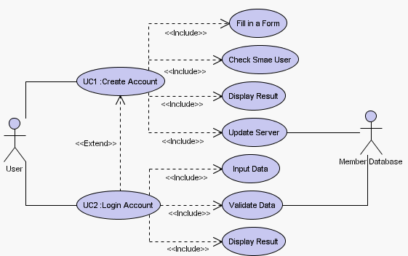

UC2: Login Account

Primary Actor : | User
Preconditions: | User has registered an account
Post-conditions | System enters main frame
Main Success Scenario: | - User opens the software.  - User enters user name and password.  - System validates the user data.  - System returns a login result.
Alternative Flows | 4a. Invalid user data  - User re-enter the user name and the password  - User creates other account in Create Account  4b. No user record  - User should create an account in Create Account (UC1)

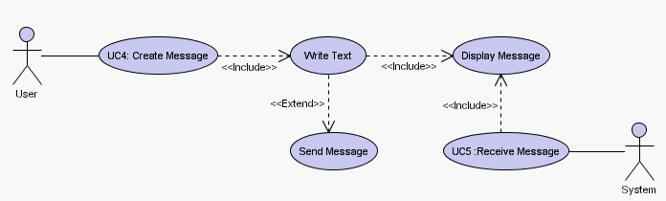

UC4:Create Message

Primary Actor : | User
Preconditions: | - User has login account successfully  - User has selected a group
Post-conditions | System returns to select functions state
Main Success Scenario: | - User selects messenger panel.  - User writes message.  - User clicks “Send” button to send out the message.
Alternative Flows | 3a. Lost Connection  - User restarts the system

UC5: Receive Message

Primary Actor : | System
Preconditions: | User has login account successfully
Post-conditions | System returns to Messenger
Main Success Scenario: | - System receives a message.  - System displays the message in the screen.
Alternative Flows | None

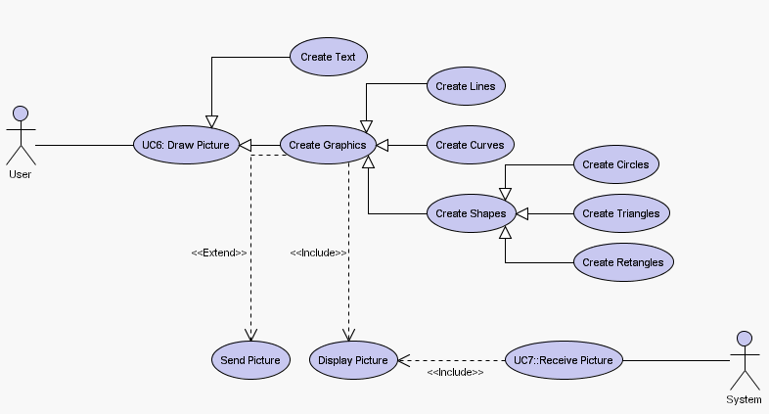

UC6: Draw Picture

Primary Actor : | User
Preconditions: | - User has login account successfully  - User has selected a group  - User has selected Drawing Board
Post-conditions | System returns to Drawing Board
Main Success Scenario: | - User selects a drawing panel  - User clicks functional button in “Function Panel”  - User draws a picture  User repeats 2-3 until the picture is done.  - User clicks “Send” button to send out the picture.
Alternative Flows | 4a. Lost Connection  - User restarts the system

UC7: Receive Picture

Primary Actor : | System
Preconditions: | - Use has login account successfully  - User has selected Drawing Board
Post-conditions | System returns to Drawing Board
Main Success Scenario: | System receives a picture  System displays a picture in the screen
Alternative Flows | None

Class Diagram
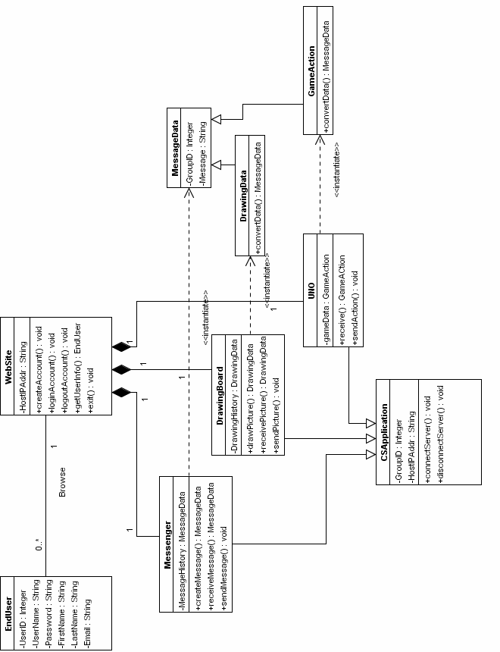

EndUser
UserID : Integer – The unique number of a user which generate by database
UserName : String – The user name of user
Password : String – The password of user
FirstName : String – The first name of user
LastName : String – The last name of user
Email : String – The email of user

WebSite
HostIPAddr : String – The IP Address of server which client program to connect
createAccount() : void – Create new user account
loginAccount() : void – Login user account
logoutAccount() : void – Logout user account
getUserInfo() : EndUser – Get user information from database
exit() : void – Exit Software

Messenger
MessageHistory : MessageData – Store the history of message
createMessage() : MessageData – Create the Message
receiveMessage() : MessageData – Receive the Message from server
sendMessage() : void – Send Message to server

DrawingBoard
DrawingHistory : DrawingData – Store the drawing history
drawPicture() : DrawingData – Draw Picture
receivePicture() : DrawingData – Receive Picture from server
sendPicture() : void – Send Picture to server

UNO
gameData : GameAction – Store the game data
receive() : GameAction – Receive game action from server
sendAction() : void – Send game action to server

CSApplication
GroupID : Integer – Store the id of a group
HostIPAddr : String – The IP Address of server which client program to connect
connectServer() : void – Connect to server
disconnectServer() : void – Disconnect to server

MessageData
GroupID : Integer – Store the id of a group
Message : String – The content of the message

DrawingData
convertData() : MessageData – convert the drawing data to message data

GameAction
onvertData() : MessageData – convert the game action to message data

Sequence Diagram

SD1: Use messenger to communicate with others.

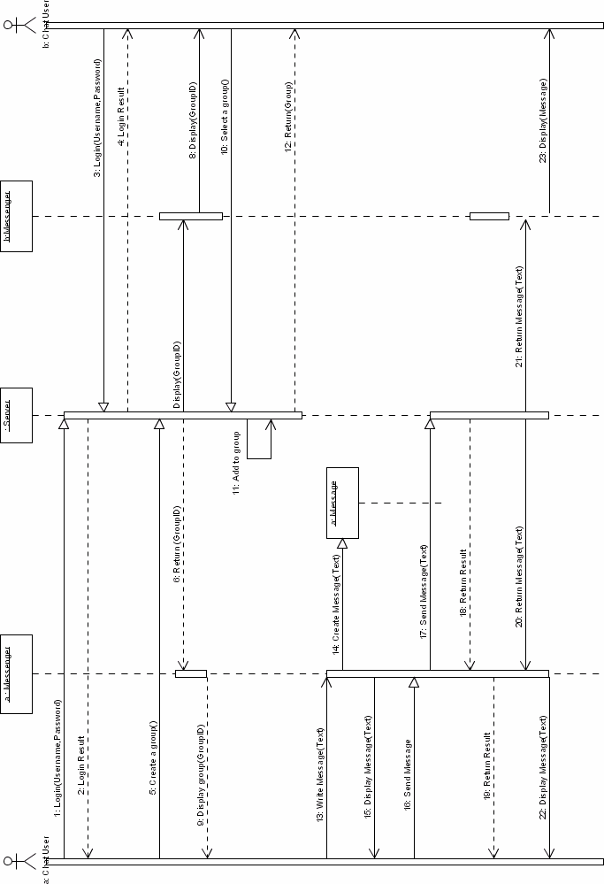
Use messenger to communicate with other users.

User A and User B enter usernames and passwords to log in the system, the server sends back the login result. Users (represents User A and User B) may create and select a group to join in. The server returns the groupid of the selected group to User A, and displays the groupid to the messenger. The messenger shows user B the groupid that has been created. User B may also select a group to join in, the server will add the users to their selected group.
After the server adds the groups, the server returns the group information to User B.

While User A write message, the messenger creates a “message” and displays the message to User A. This “message” will be sent out when User A calls the “send(message)” function. The server will return the sent result to the User A.

The sent message will be sent to the messenger at the B side. The messenger will display the sent(message) to User B.

Phototypes
Once the software is launched, user login to account using his or her username and password.
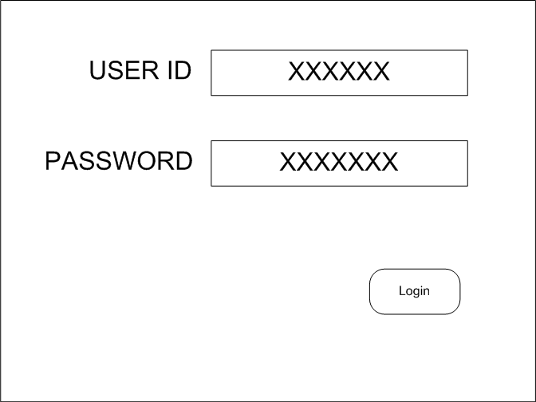
An Error message will be shown if the password is incorrect.
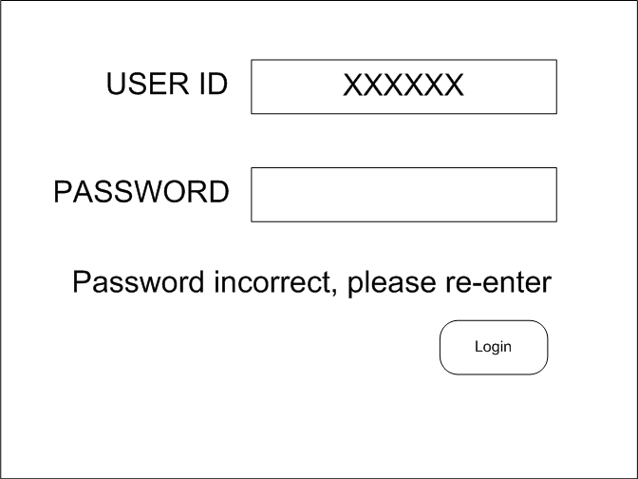

If the user does not have their accounts, user can click a hyperlink “click here” to register a new accounts in webpage.
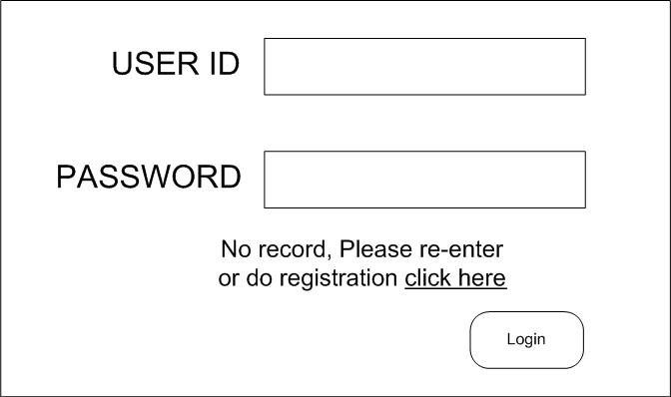

After login to user account, the user will go into Messenger and menu part.
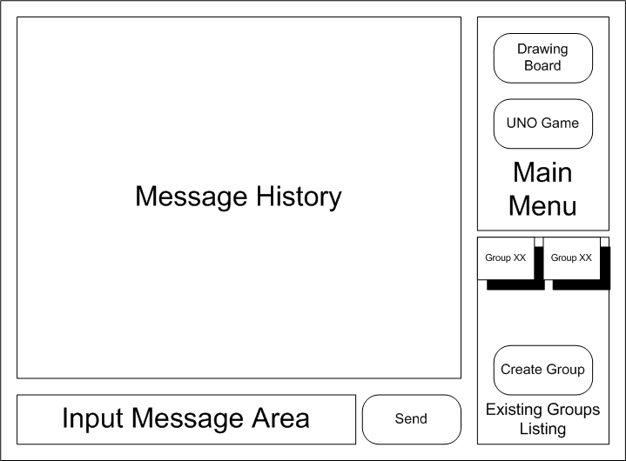

User can send the message to other users by clicking “Send button”.
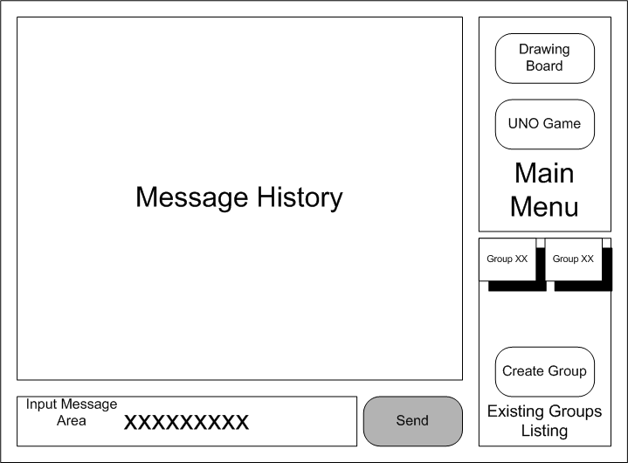

Receive the message from other users here.
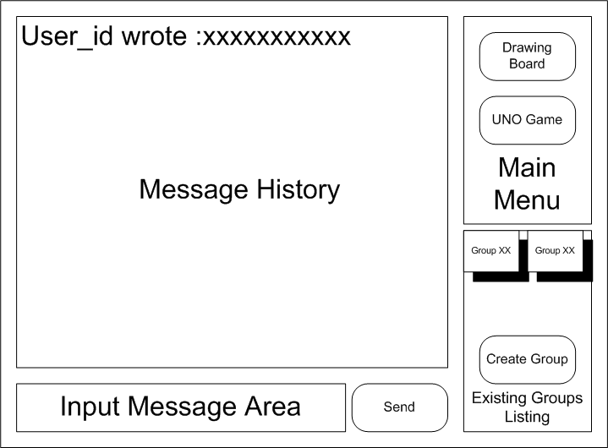

User can go to drawing board by clicking the button in the menu, and then drawing panel will be invoked.
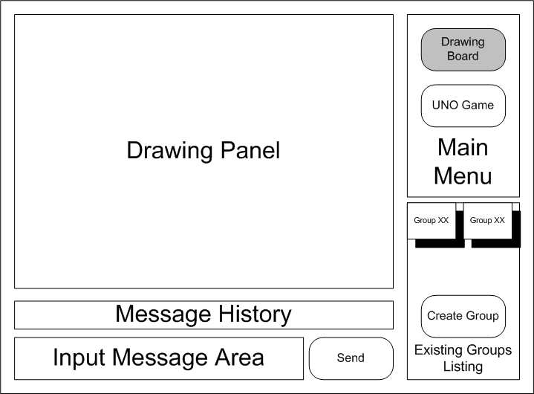

At that time, User should choose one existing group to join. Otherwise, drawing panel is in waiting state.
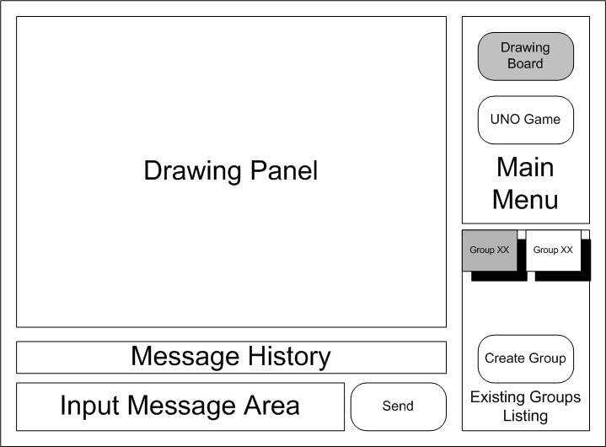
After a group is selected, drawing panel will be in active mode. User can draw a picture and press “send button” to trigger send action. When “Back to Main Menu” button is clicked, drawing panel will be closed and back to main menu.
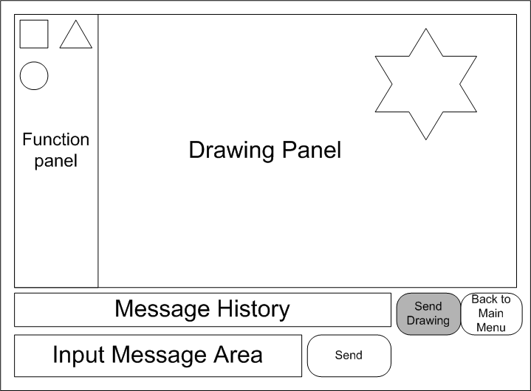

User can go to drawing board by clicking the button in the menu, and then drawing panel will be invoked.
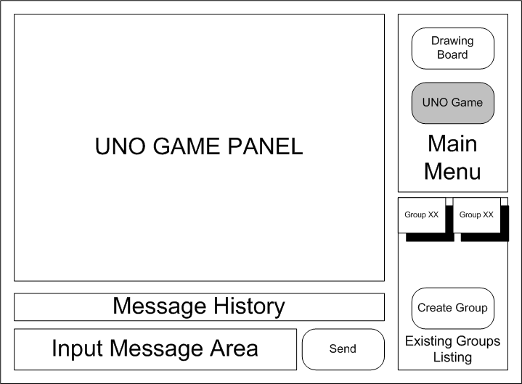

At that time, User should choose one existing group to join or create a new group. If there is not enough users in the group, game panel is in waiting state waiting other users.
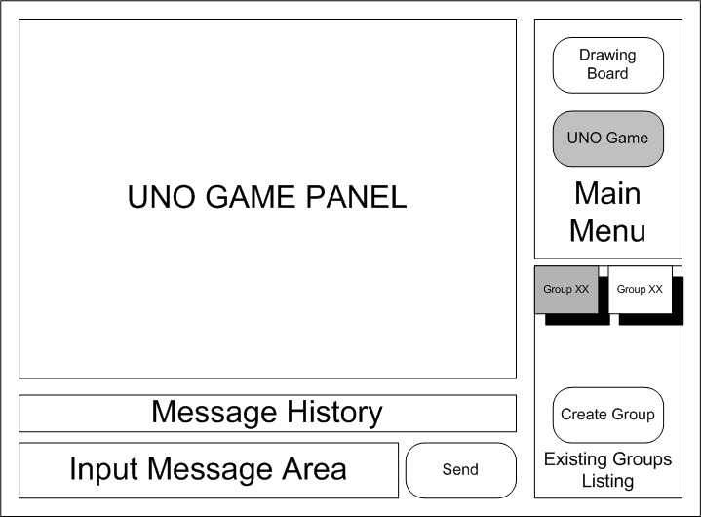

Create a new group
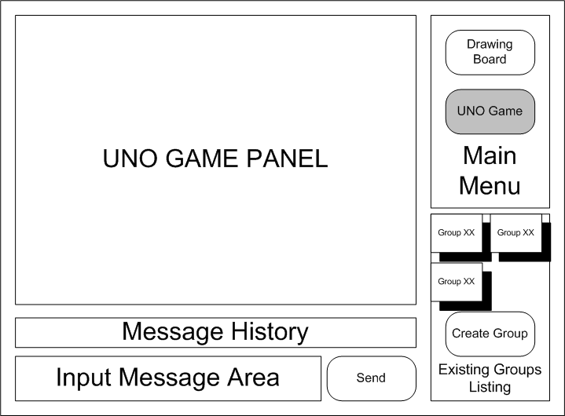

After a group is selected, UNO game panel will be in active mode. User can play a UNO game with other users in a group. When “Back to Main Menu” button is clicked, UNO game panel will be closed and back to main menu.

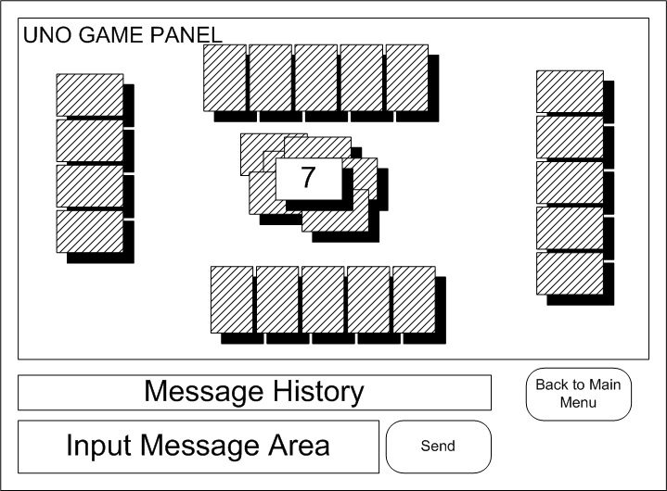

Finally, if user wants to close the software, user just clicks the close button and the software will exit.

