Digi Q
Mobile Pet Project
Requirement and Specification

Group 9:
Cheung Yin Ling Jessica 03011593
Ku Wing 03011666

Date: 11th October, 2004

Work distribution:
Jessica: part 1, part 3, part 4
Wing: part 2, part 4, part 5
Table of Content
Page no.
- Introduction 3
  - Goals and objectives 3
  - Statement of scope 4
  - Software context 5
  - Major constraints 5
- Usage scenario 6
  - User profiles 6
  - Use-cases 6
- Data Model and Description 7
  - Data Description 7
    - Data objects 9
    - Relationships 11
- Functional Model and Description 12
  - Description for Function 12
  - Function flow diagram 13
  - Function interface description 17
- Restrictions, Limitations, and Constraints 19
  - Hardware Limitations 19
  - Technical Restrictions 19
  - Implementation Constrains 20
  - Assumptions 21
- Appendices 22
  - Mindmap 22
1. Introduction
Several years ago, a pocket digital pet, Tamagochi, gain an extreme success all around the Asia. With a rapid increase of mobile phone usage, people are longing for tools that make their life happier and more convenient. Therefore, mobile gaming will be a key in driving the growth of mobile content and entertainment services.

A software design company, Digital Soft, proposed to invent a mobile game which is based on traditional digital pet functions. This mobile pet software calls Digi Q, i.e. digital queen. Players have to take care of a pink rabbit with different ways. The mobile pet will also provide more add-ons features in order to cope with the needs of mobile phone users.

1.1 Goals and Objectives
The main objective of the software is to provide not only entertainment but also a informative and educational interface for teenagers and citizens. And there are a number of goals to be achieved:

- to facilitate a digital pet on mobile phone
- to provide static useful information for mobile user
- to encourage the learning through mobile phone in anytime and anywhere
- to keep contact to the ever-changing world instantly
- to enhance mental development by taking care of the digital pet

1.2 System Statement of Scope
1.2.1 General Requirement

- A way in which user can pick a new pet.
- A way in which user can name their pet.

- Entertainment:
- A way in which users can play card matching game with the pet.
- A way in which users can feed the pet with carrots or snakes.
- A way in which users can instruct the pet to sleep.

- Education:
- A way in which mental tests can be randomly generated for user
- A way in which user can select topics they interested in little encyclopedia
- A way in which idiom story can be randomly generated for user

- Information:
- A way in which news, weather report and bus routes can be retrieve in database embedded.
- A way in which user can find out Chinese meaning of English word through dictionary in database embedded.

- User Interface:
- A colorful and simple interface for mobile phone.

1.2.2 Extended Enhancements
- Adding Different Character
More character, such as cat, dog and bear can be added to the game in order to make it more funny and interesting.

- Public transportation searching
In addition to bus route searching, further enhancement can be conduct by providing more functionality on other public transportations. This system may even work with GPRS, helping mobile user to travel around the world with the cooperation of local transportation company or government.

- Server side database
All data will be embedded into the mobile phone in this project. For further development, more informational and educational feature should be added. In order to provide enough storage of the information, a server side database belonging to mobile phone service provided should be created. Service provider could earn money by providing useful and instant information to their customers.

- Web-based community and e-shopping
Users can create their own pet and but stuff for their pet through the e-shop on the web. As a result, the pet become more unique and personal. A web-based community can be developed for different user to communicate with each others, sharing experience on dressing and taking care of their pets.

1.3 Software Context
The system is stand alone at this stage. The information of digital pet and other dictionary stuff will be embedded into the mobile phone. For instant information, user will send request to their service provider to retrieve information individually. No concurrency control has to be enforced at this stage. However, the memory space of mobile phones are limited, a database server is needed for storing a large amount of data in long run.

1.4 Major Constraints
We are not familiar with the mobile phone internal configuration and the J2ME. We shall not have too complicated coding so that the executions can be carried out faster. Also, We have to control the size of the application and the data set carefully due to limited storage of mobile phone. We need to stick on one particular specification for our software development as the OS varies from brand to brand.

There are both hardware limitations and technical restrictions. We have to read lots of specification documentations within a short time to learn more about the way to develop applications on mobile phones. We also make some assumption to simplify the system and increase the feasibility.

More details are discussed in Part 5.
2. Usage Scenario

2.1 User Profiles

There will be only one level of user:

- End-user (Mobile phone users)

End-users have basic knowledge of the usage of mobile phone, like how to control the keypad, how to access the functions of the cell phone, etc. They may not be familiar with Java games or Java applications. However, the user-friendly interface of the software can help end users to control the software.

2.2 Use-cases

End-users will be able to have interactions with the pet, e.g. feeding it. They will be able to lookup information through the pet and get some knowledge randomly up on their request. They can monitor and control the conditions of the pet, whether it is happy or not, is it healthy, and so on.

Most of the actions performed by the end-users are read-only. They will not be able to modify data or add new data. They can only control the status of the pet using different interactive functions. There are no settings available to end-users. The interface will not be changed by end-users.
3. Data Model and Description
  - Data Description
Major Inputs:
- Pet’s name
The name of the pet designed by the use when picking a new pet
- Input Destinitaion
The destination on bus route searching
- Input starting point
The starting point on bus route searching
- Input for dictionary lookup
The English word that user search for the meaning in dictionary
- Menu choosing
Moving form menu to menu by using the function key on mobile phone
e.g. main panel > information > news > sports
- Leaving that menu
Using the cancel button on the mobile phone
- Leaving the game
Using the end phone call button on the mobile phone

Major Outputs:
All output interfaces are according to the interface prototyping in functionality session.

- General output
- pet’s status
Happiness, hunger and sleepiness of the pet will be displayed on main panel
- pet’s face
Different faces, e.g. happy, excited, cry will be displayed according to the status
- output after help key on panel
Display definitions of all buttons after click on “help” on the panel.
- output after help key in play mode
Display how to play matching game in detail after click on “help” in play mode.
- Output when leaving that menu
Return to the previous menu

- Searching results in dictionary, bus route, weather and news:
- Bus route
Display the searched route with bus number and all bus stops in that route with highlighted start and destination input by user
- Today’s Weather
Display today’s weather in temperature, humidity and description image
- News in different title
Display the selected category, heading and details of that piece of news

- Random results of idiom story and encyclopedia
- Idiom’s details
Display the selected category, randomly output title and information on that area
- Encyclopedia
Display the selected category, randomly output title and information on that area

    - Data Objects
- Pet
  - Name
Name of the pet
  - Happiness
The happiness state of pet
  - Hunger
The hunger state of pet
  - Sleepiness
The sleepiness state of pet
  - Carrot_ate
The count of carrot ate by the pet use to calculate the probability of growth
  - Exist
The Checklist specify whether a pet exist

- Game
  - Card_open
The Checklist specify whether the game card is open
  - Face
The content of the card
  - Chance
The total number of chance the user has

- Bus Route
  - Bus_number
The bus number of a route
  - Total_nodes
Total number of bus stop in this route
  - Bus_nodes
All the nodes included in this route

- Dictionary
  - English
English words input by the user
  - Chinese
Chinese meaning of the English word

- Mental Test
  - Tiltle
Titles of the mental test
  - Question
The questions and choices for this question
  - Answer1
The result when choosing answer 1
  - Answer2
The result when choosing answer 2
  - Answer3
The result when choosing answer 3
  - Answer4
The result when choosing answer 4

- Encyclopedia
  - Encyc_Area
Area of the Encyclopedia, e.g. astronomy, geography and biology
  - Topics
Topics for specific area
  - Information
Information of the topic

- News
  - News_Area
News in specific area, e.g. headline, finance and sport
  - New_heading
The topics for specific area
  - New_detail
The details of the piece of news

- Weather
  - Temperature
Today’s outdoor temperature
  - Weather_state
The state describes today’s weather, e.g. sunny, cloudy and rainy
  - Humidity
Today’s outdoor humidity in percent

- Idiom Story
  - Idiom
The field contains idioms
  - Background
The Backgrounds of the idioms
  - Meaning
The meanings of the idioms
  - Example
The examples of the idioms

    - Relationship

Pet
Name
Happiness
Hunger
Sleepiness
Carrot_ate
Exist
Game
Card_open
Face
Chance
Idiom_Story
Idiom
Background
Meaning
Example
Bus Route
Bus_number
Total_nodes
Bus_nodes
Encyclopedia
Encyc_Area
Information
News
News_Area
New_heading
New_detail
Weather
Temperature
Weather_state
Humidity
Mental Test
Tiltle
Question
Answer1
Answer2
Answer3
Answer4
Dictionary
English
Chinese

4 Functional Model and Description
4.1 Description for Function
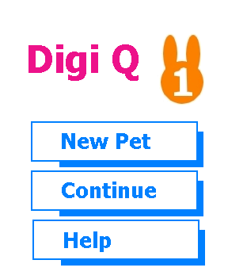
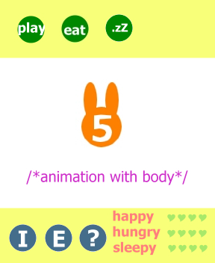
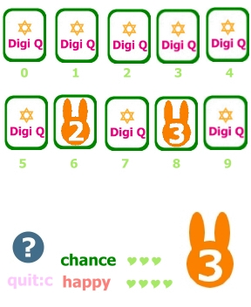
4.1.1Start-up Menu
When the application is run, this menu comes up. Users can choose the option by pressing the up and down arrows on the keypad. The chosen option would be highlighted. The detailed start-up function description can be found in section 4.x.x
4.1. 2 Main Menu
Six options are available on the main menu. Also, the name of the pet will be displayed on the top-right corner. The three options on the top are play, eat and sleep, which are instructions to the pet. After choosing the option using the left and right arrows, a new interface would be displayed. Informative, educational and help features are listed below. They can be access using left and right arrows too. A relative menu will be display after choosing these options. We can also see the pet in normal condition at the middle and it’s condition indices at the bottom-right corner.
4.1.3 Playing with the Pet
Here’s the playing interface. This is a simple card matching game. Users can use the number keys on the keypad to turn over two cards. If the chosen cards are of same emotion icon, the happy index of the pet will increase, decrease if otherwise. 10 new cards will be generated after 3 wrong guess.
4.2 Function and Flow diagram

4.2.1 Informative
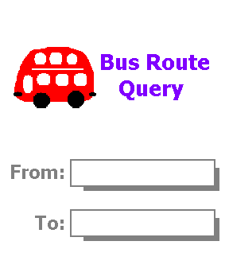
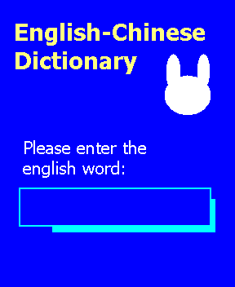
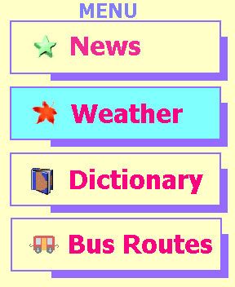
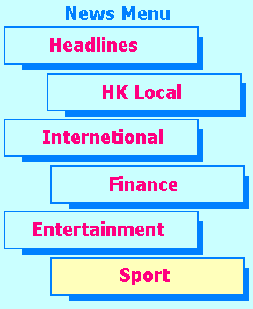
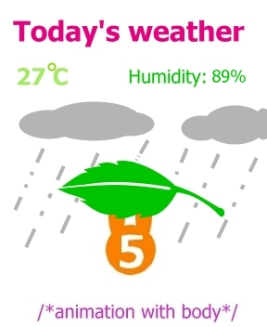

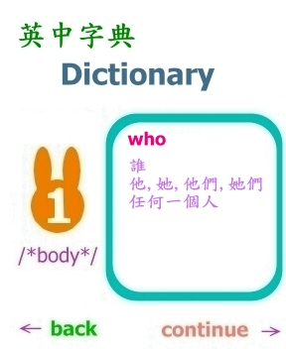
News
Dictionary
Bus Routes
Weather

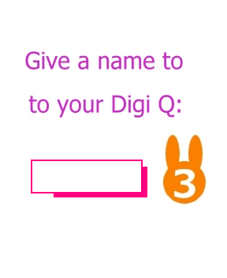
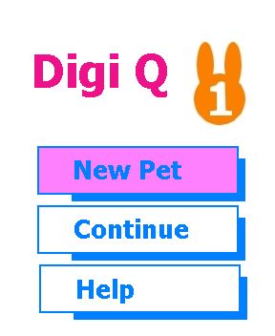
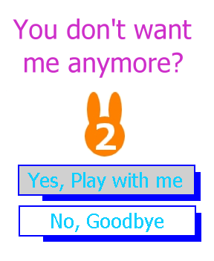
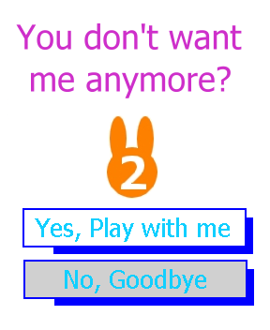
With Existing Pet
Without Existing Pet
4.2.2 Create New Pet
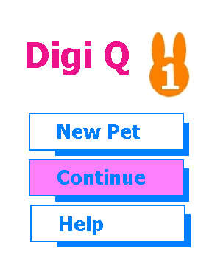
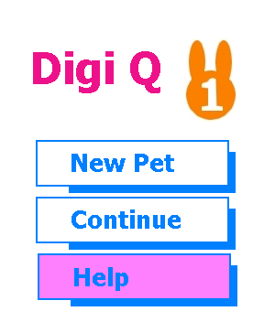
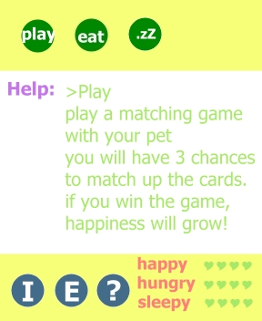
4.2.3 Continue with Existing Pet
4.2.4 Get Help
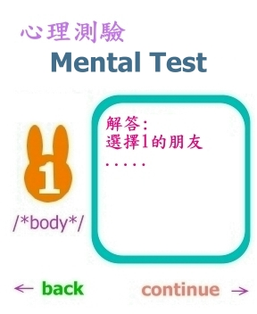
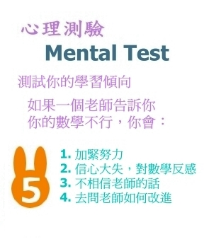
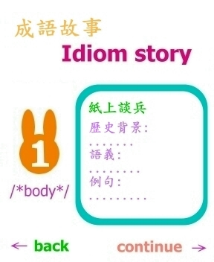
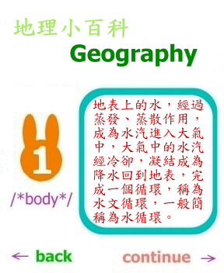

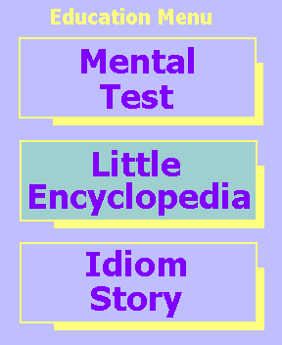
4.2.5 Educational
Mental Test
Idiom Story
Little Encyclopedia
4.3 Function and interface description

4.3.1 Informative
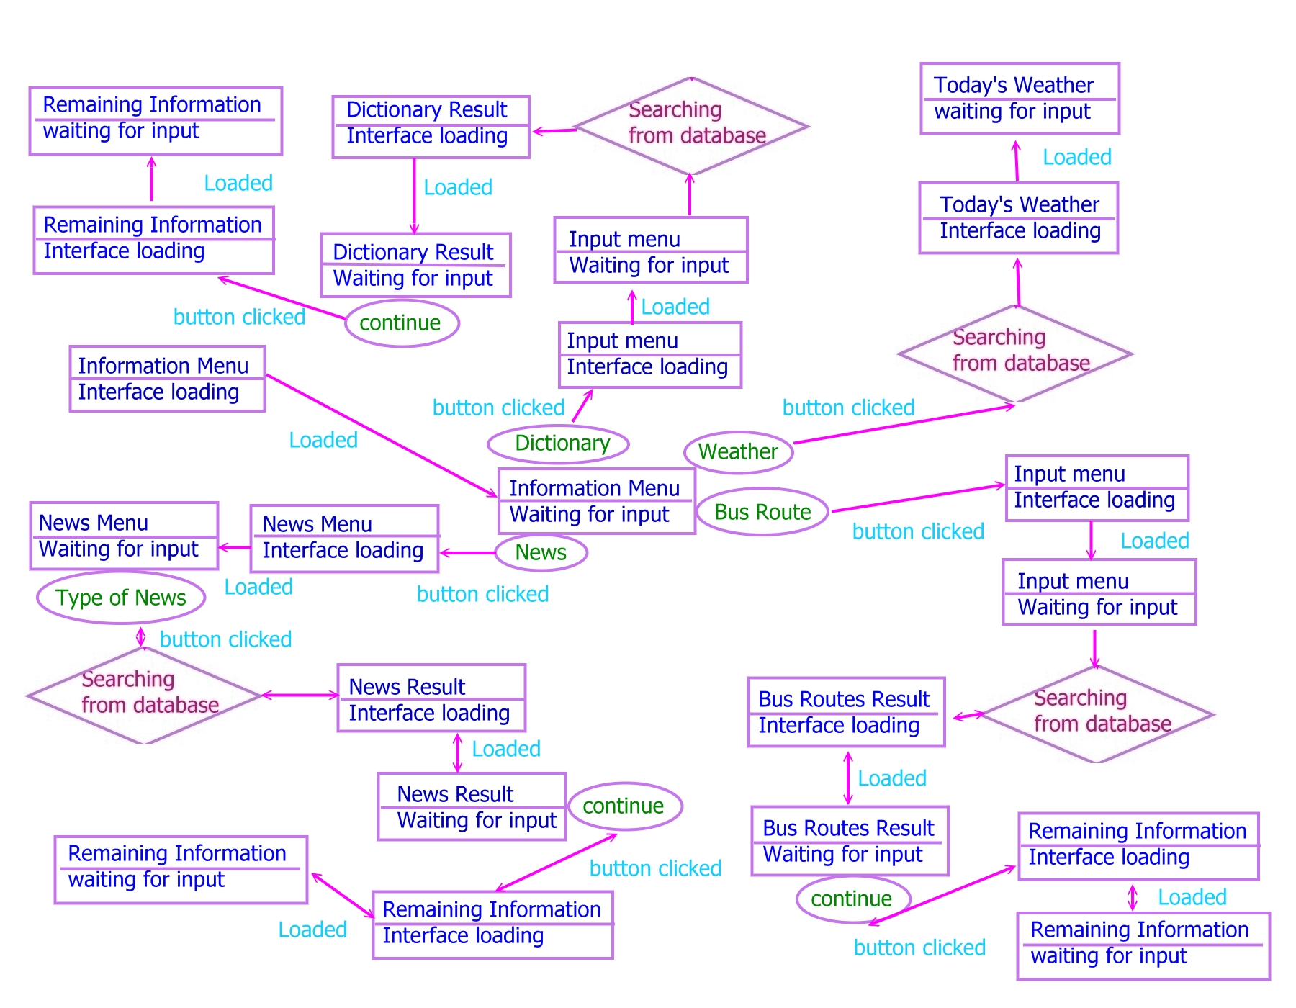
4.3.2 Educational
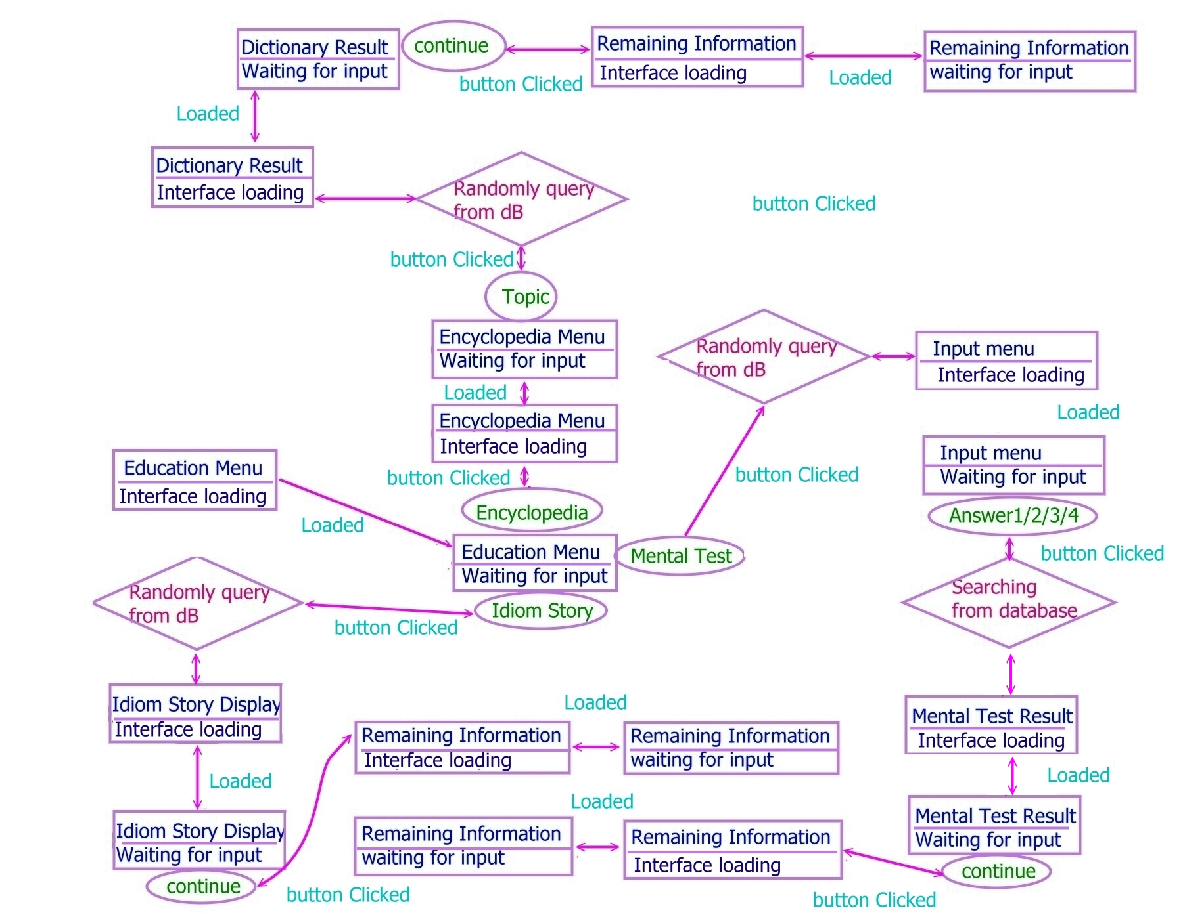

- Restrictions, Limitations, and Constraints

  - Hardware Limitations

    - Application Size
Mobile phones have a very limited amount of memory available for additional applications. Thus the complexity of the software has to be as low as possible. Also, we shall not create large data set for the application.

    - Sounds
Applications on mobile phones have limited ability to play sounds. It is difficult to control the sounds by J2ME programs, since the J2ME specification does not require hardware manufactures to support sound at all. Though primitive Java phone allow the use of some sounds, sounds are not essential for our software. To decrease the complexity of the software so that it can run faster, we do not included any sounds.

    - Screen Size
The screen of mobile phones is quite small; we cannot put lots of information or text on the same page. Also, the design of the interface has to be simple and clear, without many details.

  - Technical Restrictions

    - Interrupt Handling
Users may receive voice calls or messages during they are accessing the software. Thus we require specification documentations to help us with the coding, so that the software is able to pause and recover without crashing or causing memory leaks when interrupts occur.

    - Latency
It takes microseconds between making a request and receiving a response on stand-alone mobile phones. Lags would be observed when user request information from database. For further development, the data will be retrieved from remote database; it will take seconds to transmit the request and response over the air network. The latency will be increased. However, the required space for the data set storage will be highly decreased. At this moment, we will embed the database to the phone due to limited time and knowledge.

  - Implementation Constrains

    - J2ME
We studied Java programming before, but we know very little about J2ME, especially for graphics and animation handling. We have to study J2ME before we start to implement the software within a few weeks or a month. We may not produce the same interface as the prototype.

    - Testing Platform
There are various mobile phone manufacturers; the OS produced by different brand names varies. To cop with the specification, we focus on developing the software base on nokia mobile phone. However, we do not have an experimental mobile phone to implement the software. We will use phone simulator that runs on windows platform to test the software.

    - Limited Storage
The storage size of mobile phones is very limited. But we need to store the dictionary, news, weather, idiom stories, etc. It is impossible to store all of them inside the mobile phone. Since we do not have the server knowledge and we do not know the data transfer principles between remote database and mobile phone, we cannot put the data set in remote database, which is an ideal solution. Therefore, we will include some testing cases only. We will not put the whole data set into the mobile phone.

    - Copyright
There will be dictionary and encyclopedia embedded in the software. To ensure the correctness, we have to refer to authentic dictionary and encyclopedia, which lead to copyright issues. Thus we must not copy the whole dictionary or encyclopedia as our data set unless we get the copyright.

  - Assumptions

    - Data Retrieval
We are not familiar with the communication technology between mobile phones and remote server, thus we assume that all the data is retrieved from database or text files embedded in the mobile phone.

    - Input Language
To avoid complicated Chinese word processing, all the data input from the user will be English only. That is, the input of the pet’s name, bus route query and dictionary lookup are expected to be English.

    - Bus Route Information
There are same bus route numbers from different companies, to decrease the complexity and size of the database for the ease of implementation, we assume that all the bus route information are from KMB only. Also, we only include basic information of the bus route, which are the route number and the stop names.

