BITPHOTO
Object-Oriented Design Specification
In Unified Modeling Language (UML)

by

Tong Tat Ming 03011887
Tam Wing 03011879
(Group 6)

COMP2221
Lecturer : Prof. Jimming Liu
December 4, 2004
Object-Oriented Design Specification
In Unified Modeling Language (UML)
Table of Content
1 Graphical Notations Used 4
1.1 Notation of Use Case Diagram 4
1.2 Notation of Class Diagram 5
1.3 Notation of Sequence Diagram 6
2 Introduction 7
2.1 Goals and Objectives 7
2.2 System Statement of Scope 7
2.2.1 General Requirements 7
2.2.2 Major inputs 8
2.2.3 Major outputs 8
2.3 System Context 8
2.4 Major Constraints 9
2.5 Usage Scenario 10
2.5.1 User Profiles 10
2.5.2 Use-cases 10
3 Use Case Diagram 11
4 Class Diagram 12
4.1 Class description 12
5 Sequence Diagram 16
5.1 Sequence Diagram of Photo Modifying Process 16
5.2 Sequence Diagram of Add Frame Function 17
5.3 Sequence Diagram of Add Text Function 18
6 Interface Design 19
6.1 Software Interface 19
6.2 Software user interface prototype 22
6.3 External machine interfaces 23
6.4 External System Interface 23
7 Restrictions, Limitations and Constraints 24
8 Validation Criteria 25
9 Appendixes 27
9.1 Software mind map 27
9.2 Design Mind map 31
9.3 Data object 38
9.4 Data Object Description 41
9.5 Data Sub Class Modeling 43

Graphical Notations Used

Notation of Use Case Diagram

Notation of Class Diagram

Notation of Sequence Diagram

Introduction

Goals and Objectives
The main purpose of BITPHOTO is to provide a fast and easy way for basic photo editing and label machine function. The goals of BITPHOTO are:

- To provide a basic photo editing function
- To modify common deficiency in digital photo
- To provide a light-photo editor which minimize usage of computer resources. E.g. memory, hard disk, operation time etc.
- To provide an easy use photo editor to user by user-friendly interface, icons and eliminate those not common used functions.
- To provide label machine function which user can decorate the photo and print out as photo label.

System Statement of Scope

General Requirements
The following general requirements were laid out for our project named BITPHOTO:
- A way to output the files by printing for different ways and size.
- A way to provide basic function. E.g. save, print, help, open, undo etc..
- A way to editing the photo. E.g. resize, change ratio, rotation, add text date add, watermark add.
- A way to create and edit label photos.
- A way to decorate photo as a label photo machine.

Major inputs
- Source photos in JPEG format from digital camera
- Source photos in JPEG format from the secondary memory.

Major outputs
- Softcopy of resulting image as an image file in JPEG format.
- Hardcopy of resulting image as poster.
- Hardcopy of resulting image as photo label.

System Context
Own a digital camera is popular nowadays .High pressure to our old machine was brought by large amount of image files exchange and processing. Bitphoto provide a light version of photo editor and label machine function. To minimized resources and provide basic editing function is our main target. Label photo machine is a brand new function to youngsters. Different to Photoshop ,Photoimpact , ACDsee , simple , basic and effectiveness is our main concerns. Bitphoto help to overcome the revolution constraint on releasing photo to the internet, which provide a much convenience way to share the photos.

Major Constraints
- Operation Time
For learning a new programming language and develop a software within few months. It seems too hash to develop a perfect works , we do try our best but what we concern is the operation time of the software .We want to provide more functions and better interface ,but on the other hand ,the operation time may slow down.

- Image Type
As we know that the user may have different types and formats, sizes of source images, so it is a great challenge to us to overcome we have a lot of ideas but cannot implement them due some programming constraints.

- Hardware Support
Input and output of the images need connecting pc and many hardware devices such as digital camera and printer. In order to widen the compatibility of our software we need to overcome the protocol and other constraints of the image formation.

- Computer Resource
As our target of software is to provide a light version of photo editor, thus the program size and the main memory occupation must be minimized. To be balance stability and resource occupation is our main constraint.

- User Ability
Youngsters and junior computer user are our target user .We must keep track with their requirements and computer using ability, knowledge. The variety skill level of end users is a great constraint for the user graphic interface and functions design.

Usage Scenario

User Profiles
All function will be open to every end user, our main target user is youngster who sensitive to the trend.

Use-cases
User
The user (mainly teenagers) may use all functions provided, such as basic image modifying function, and label machine function to make fun. Label machine is main target to them as most of the youngsters like to share the funny photo with their friends on the internet.

Use Case Diagram
This Use Case Diagram(Fig.3.1) is use to show the relationship between the actor and use cases. There is only one user but many actors in the diagram, and those use cases are act by them.
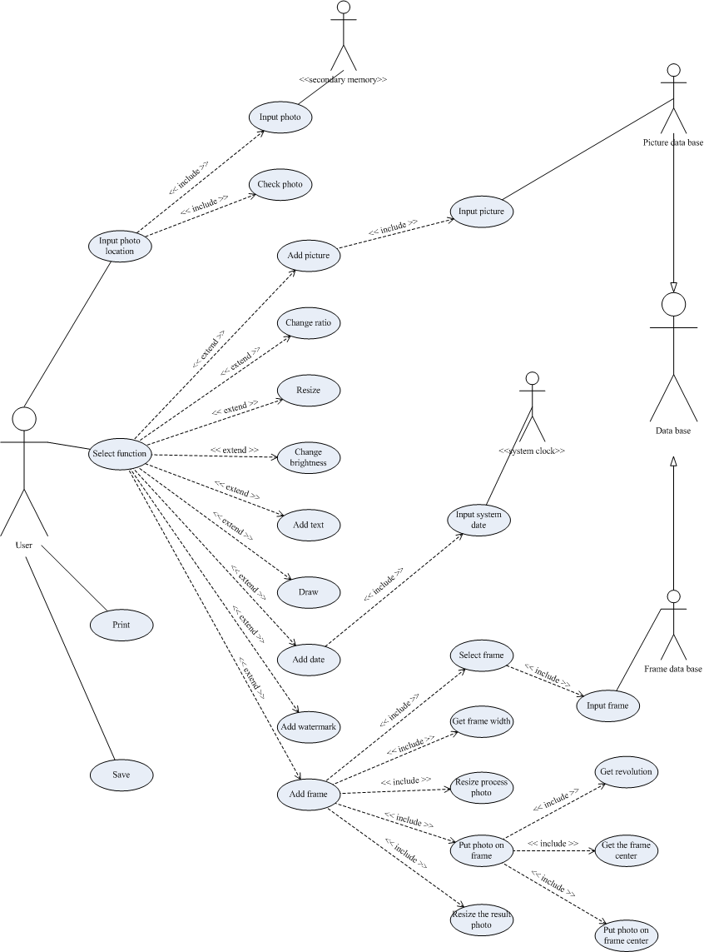

Fig 3.1 : Use Case Diagram

Class Diagram

Class description
BitPhoto
The main class is the Bitphoto class which contain the interface of the software and has simple functions (such as start or quit) but great amount of decorations as well as simple but clear interface

Photo
There are two main classes under the BitPhoto. One called Photo which consist of most image data and variables such as Name,Width,Length…etc and perform save,function,input,print operations.

Preprocess Photo
That is a class that use to store the photo before any modification

Process Photo
That is a class that use during the operations and modifications. It will contain a lot of elements inside it.

Before Last Process Photo
That is a class that use to store the process photo before the modification, it can be use as a backup photo.

Three transition classes
Photo is one of class which consist of three other transition classes Preprocess Photo, Process Photo and Before Last Process Photo which show that a photo image to be processed. Firstly, get the photo and the pass to next process and finally saved the product image at the last process. Process Photo class is the most important class which all modifying function will be took place such as Change Ratio ,Brightness, Size .

Function
The other class under Btphoto class is Functon Class that mainly divided into two main functions(tools): Label Machine Function and Basic Modifying Function which provide modifying function (change ratio,brightness,size) and Label Machine Function(Add frame,text,date…etc).

Label Machine Function
This class is use to store the function classes that work as label machine.

Basic Modifying Function
This class is used to store the function classes that work for basic modifying.

Draw
This class is used to provide the draw function on the process photo.

Add Picture
This class is used to provide the add picture function on the process photo.

Add Frame
This class is used to provide the add frame function on the process photo.

Add Text
This class is used to provide the add text function on the process photo.

Add Date
This class is used to provide the add date function on the process photo.

Add Watermark
This class is used to provide the add watermark function on the process photo.

Watermark
This class is used to show the watermark element state.

Date
This class is used to show the date element state.

Text
This class is used to show the text element state.

Frame
This class is used to show the frame element state.

Picture
This class is used to show the picture element state.

Line
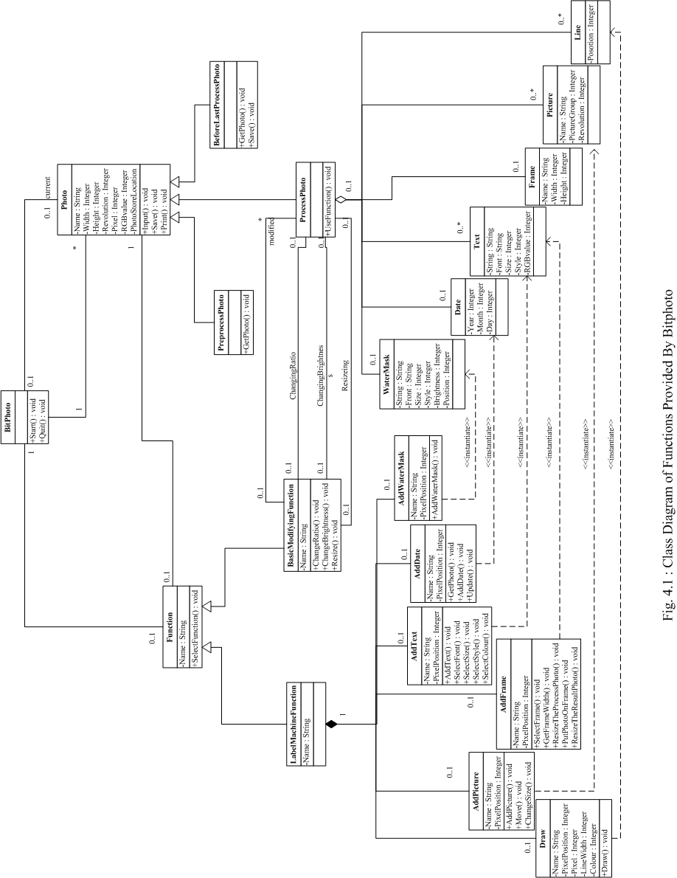
This class is used to show the line element state.

